**Worksheet -1(MST)**

**Student Name: ANSHUL VERMA                                 UID:19BCA1348**

**Branch: BCA                                                                  Section/Group:1/B**

**Semester:5                                                                     Date of Performance:1/10/2021**

**Subject Name: COMPUTER GRAPHICS LAB              Subject Code:CAP-306**

3) Given the centre point coordinates (10, 10) and radius as 10, draw a circle using Bresenham's Circle drawing Algorithm. Also plot the intermediate pixels values.

**ANS:**

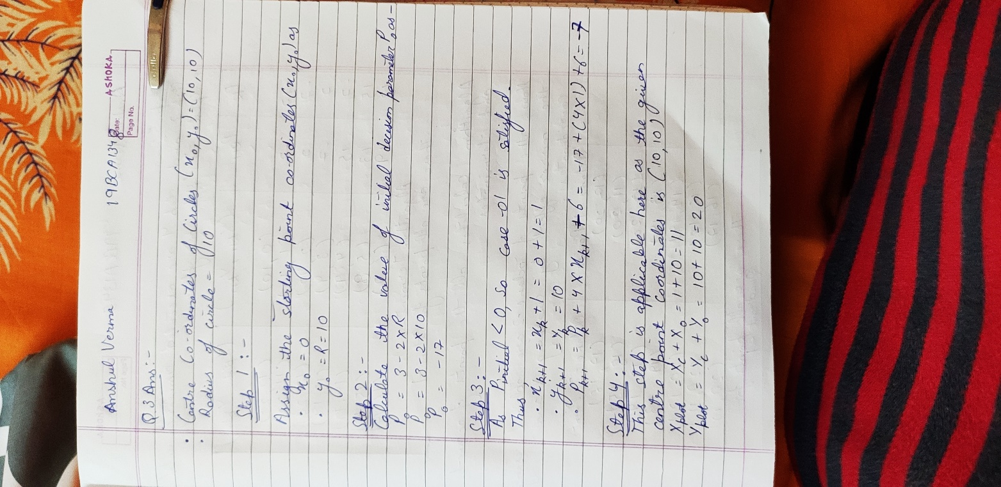

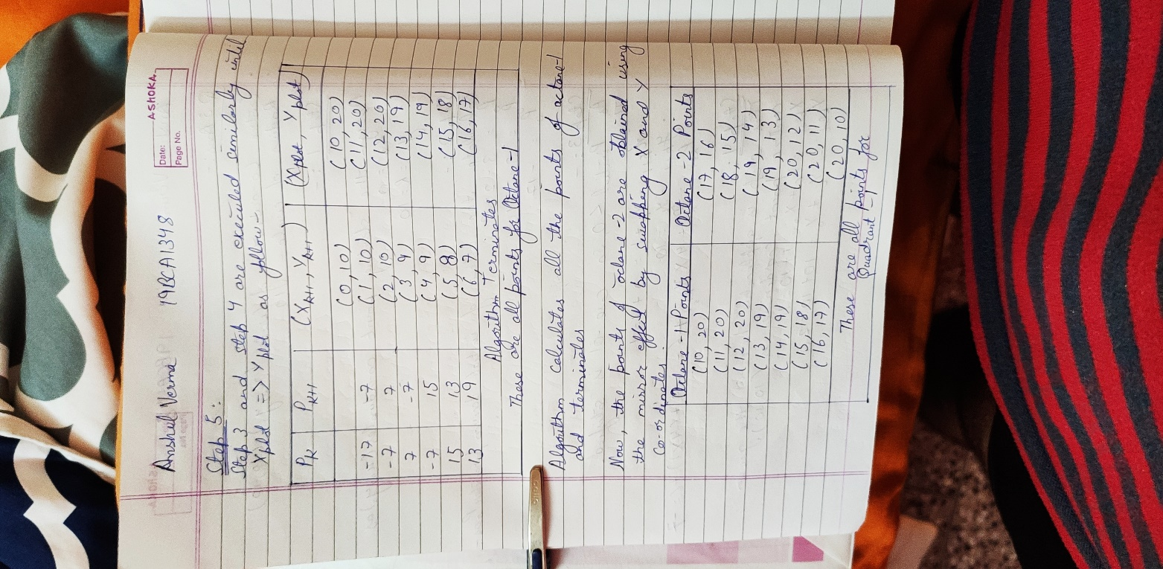

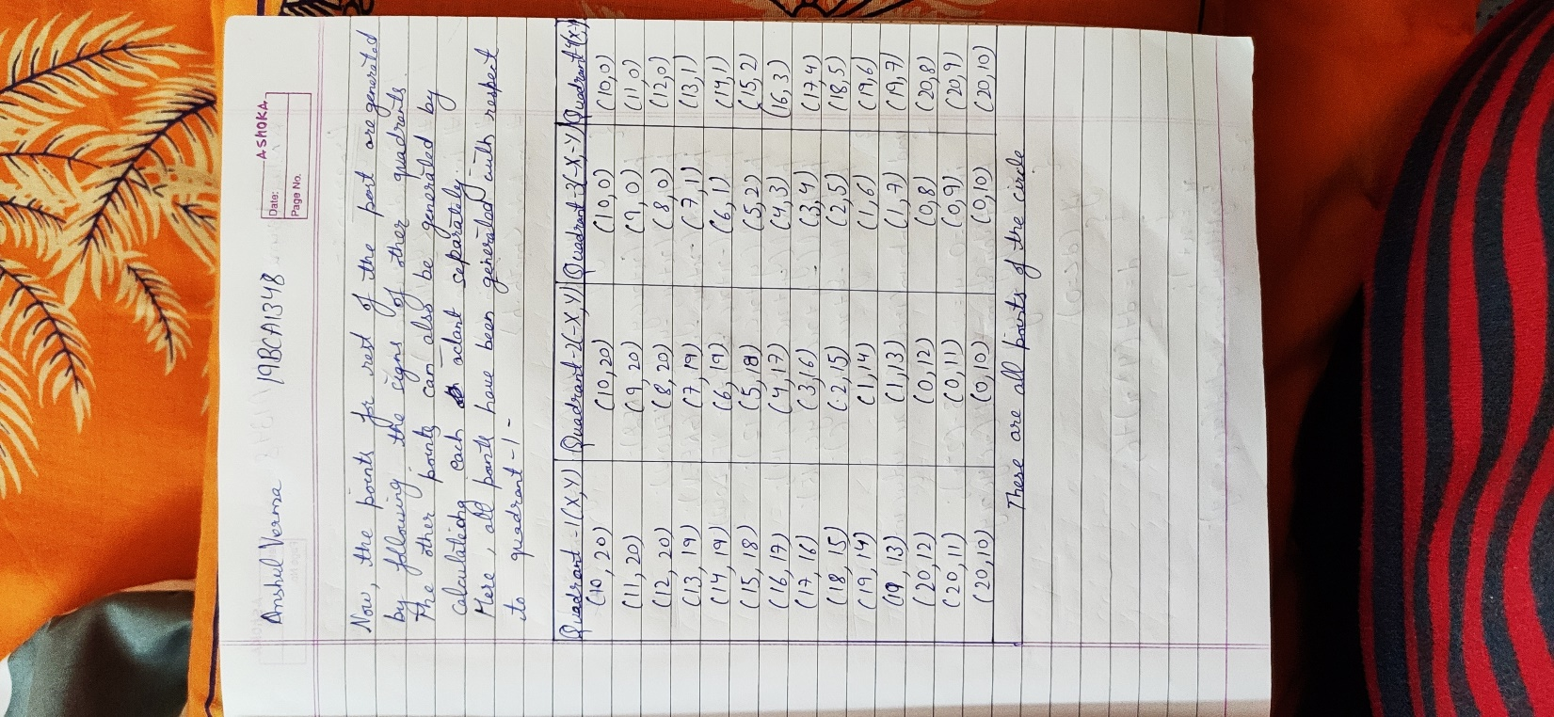

**PROGRAM:**

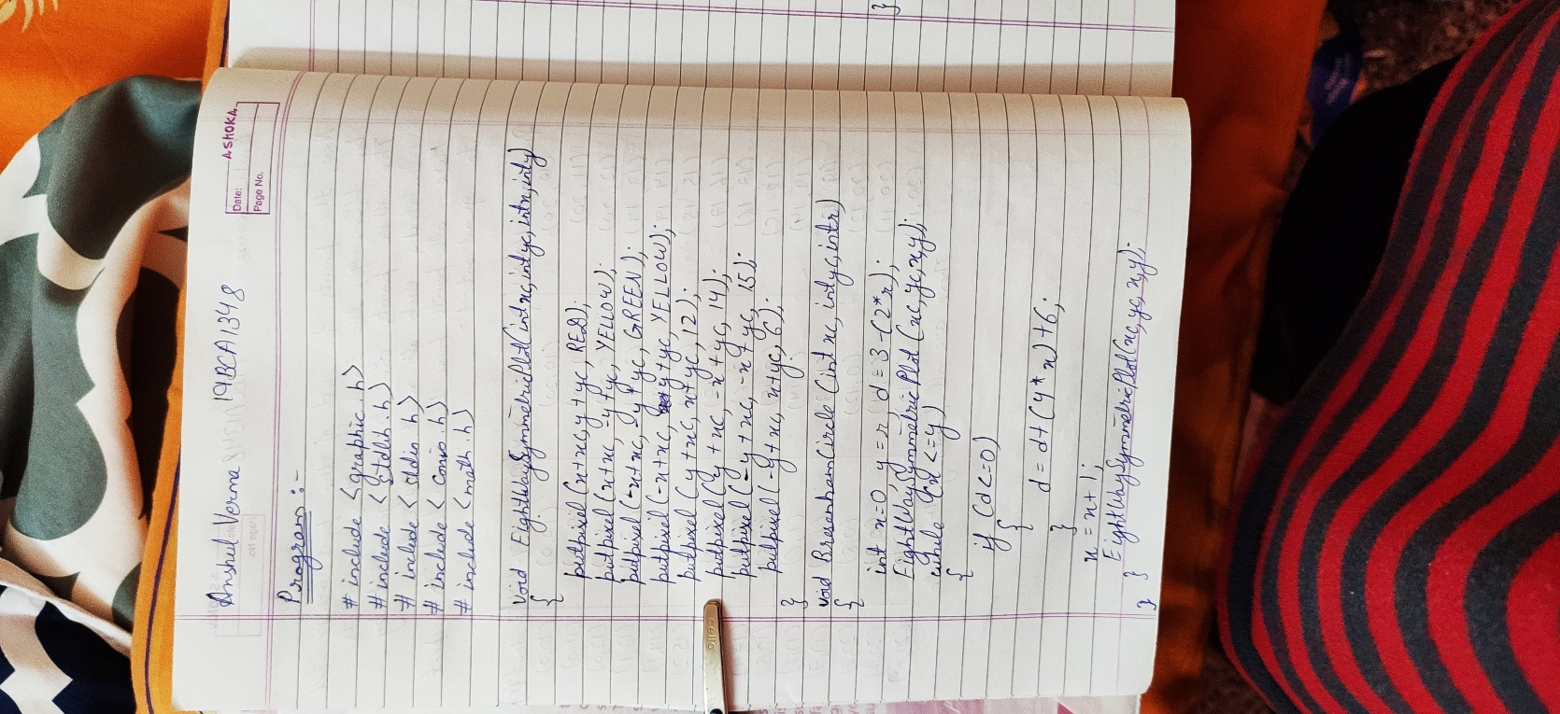

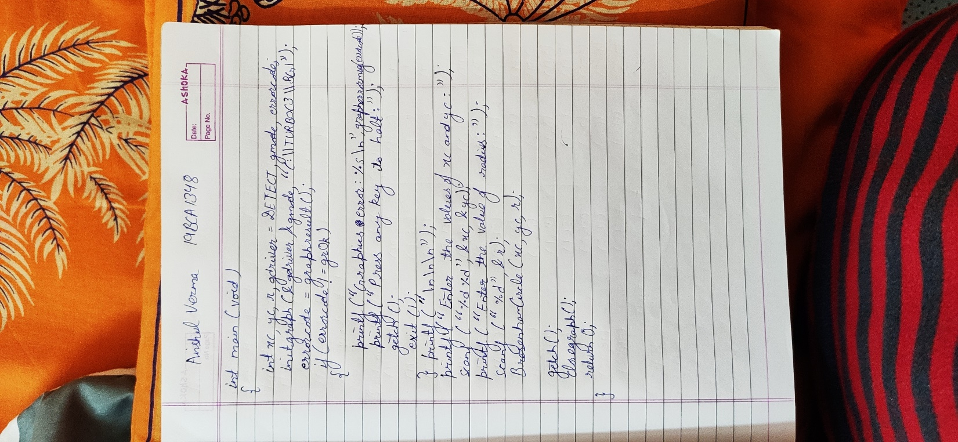

**OUTPUT:**

